Mobile Application Development

Potato Leaf Disease Identification

Team-2

Nithees M - CB.EN.U4CSE21338
R Kaviswar – CB.EN.U4CSE21345

Problem Statement:

Potato crops are vulnerable to diseases like early blight and late blight, which can severely impact yield and quality. Traditional disease identification methods are time-consuming and often inaccurate, especially in resource-limited settings. There is a need for a fast, accurate, and accessible solution to diagnose these diseases in real-time, allowing farmers to take immediate action and reduce crop losses. To address this, we propose developing a CNN-based machine learning model integrated into a mobile app to classify potato leaves as early blight, late blight, or healthy, enabling timely and informed decision-making for sustainable agriculture.

Introduction:
Potato leaf diseases, particularly early blight and late blight, pose significant threats to agriculture, affecting both crop yield and quality. Early blight, caused by Alternaria solani, results in dark spots on leaves and premature defoliation, while late blight, caused by Phytophthora infestans, can lead to rapid tissue decay and even complete crop failure. Timely and accurate identification of these diseases is crucial for effective treatment and minimizing economic losses.
To address this challenge, we are developing a convolutional neural network (CNN)-based machine learning model aimed at classifying potato leaves into three categories: early blight, late blight, and healthy. CNNs are highly effective for image classification tasks, making them ideal for detecting subtle differences in leaf texture and coloration. Our goal is to integrate this model into a mobile application, providing farmers and agronomists with an accessible tool for real-time disease diagnosis, ultimately contributing to more sustainable agricultural practices.
Model Comparison:

Models Accuracy (%)

Transformer 95.70
InceptionV3 96.87
Lenet 95.70
MobilenetV2 98.82
VGG16 94.92

Application Architecture:

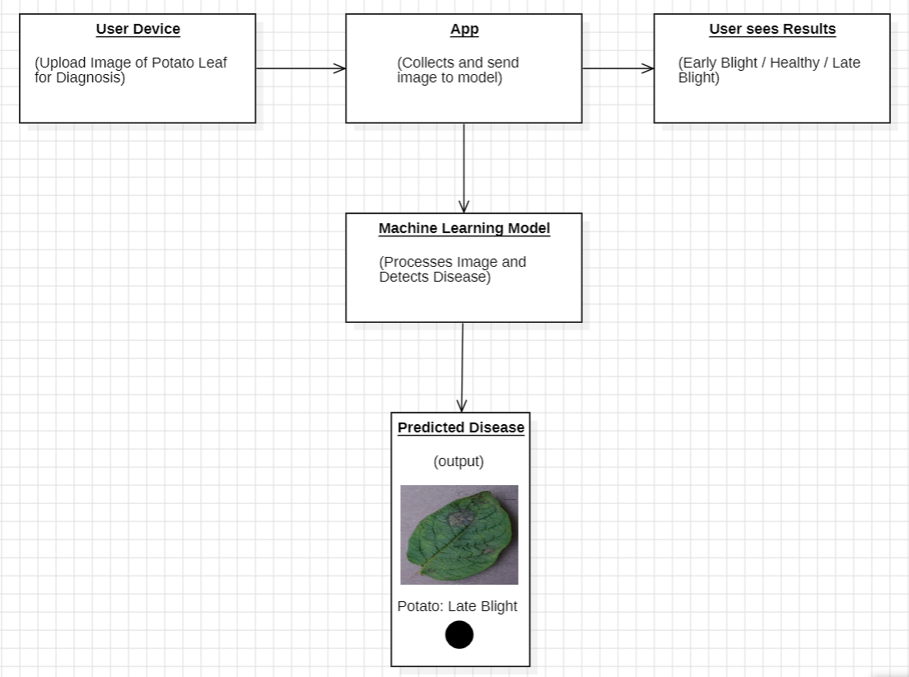

Experiments:

Transformer
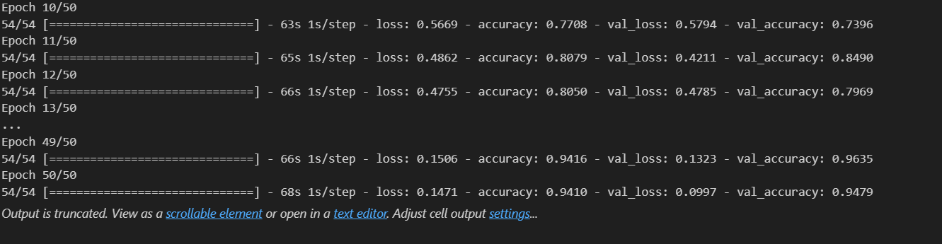

InceptionV3

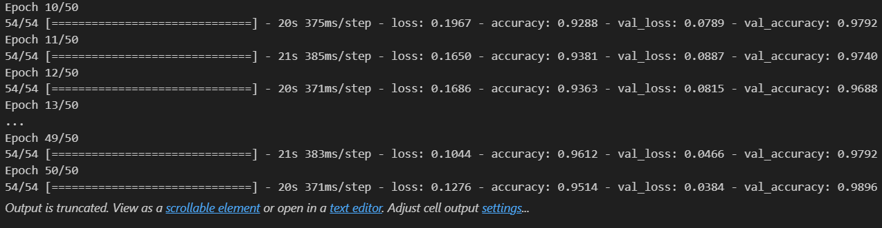

Lenet

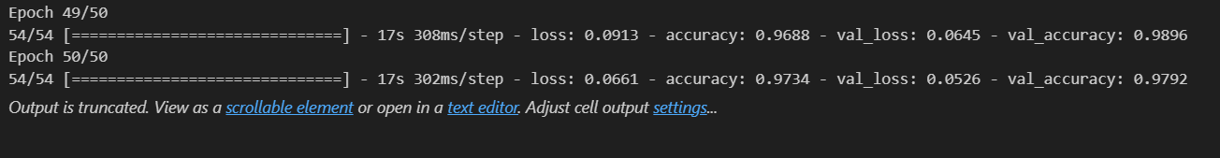

MobilenetV2

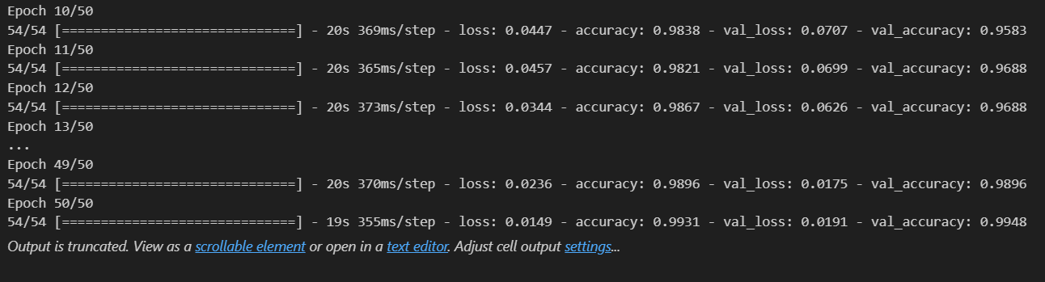

VGG16

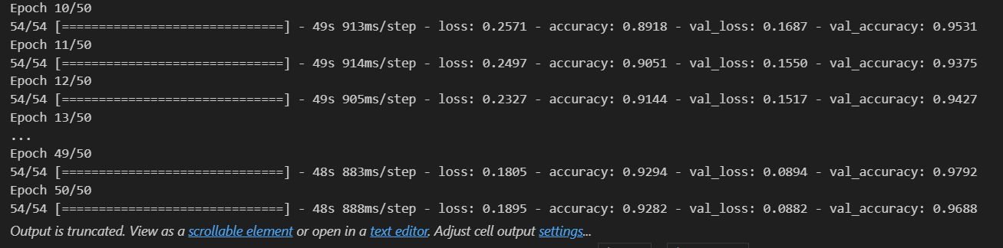

Results:

Transformer

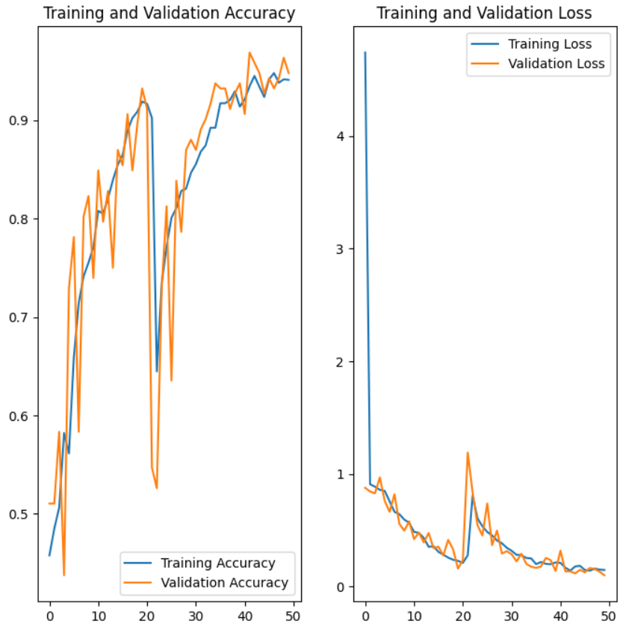

InceptionV3

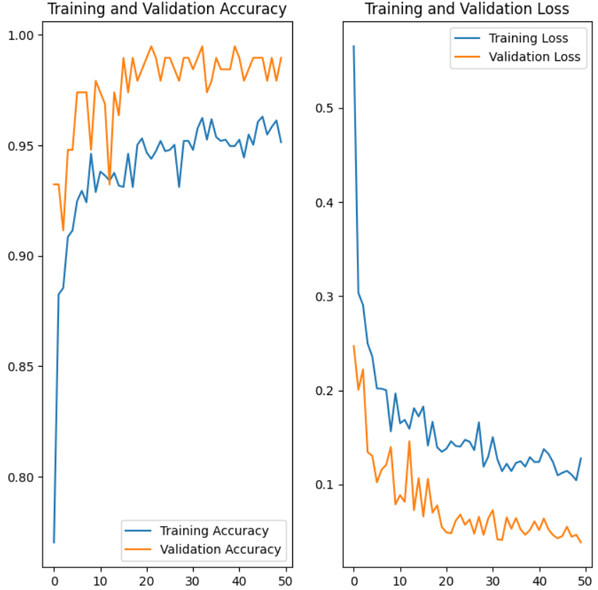

Lenet

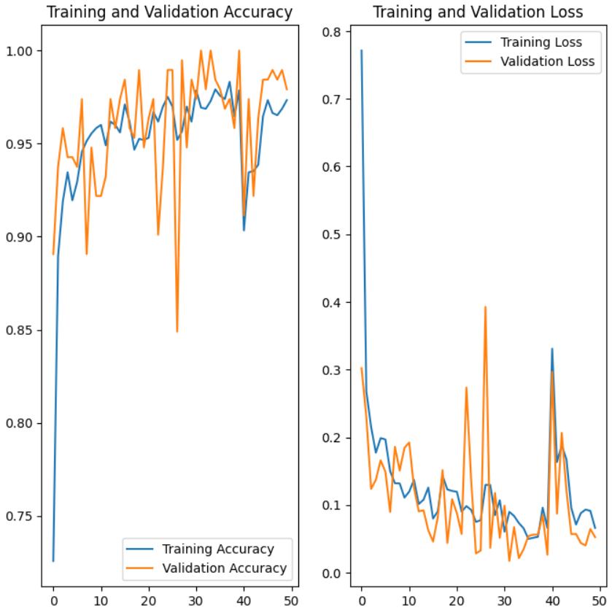

MobilenetV2

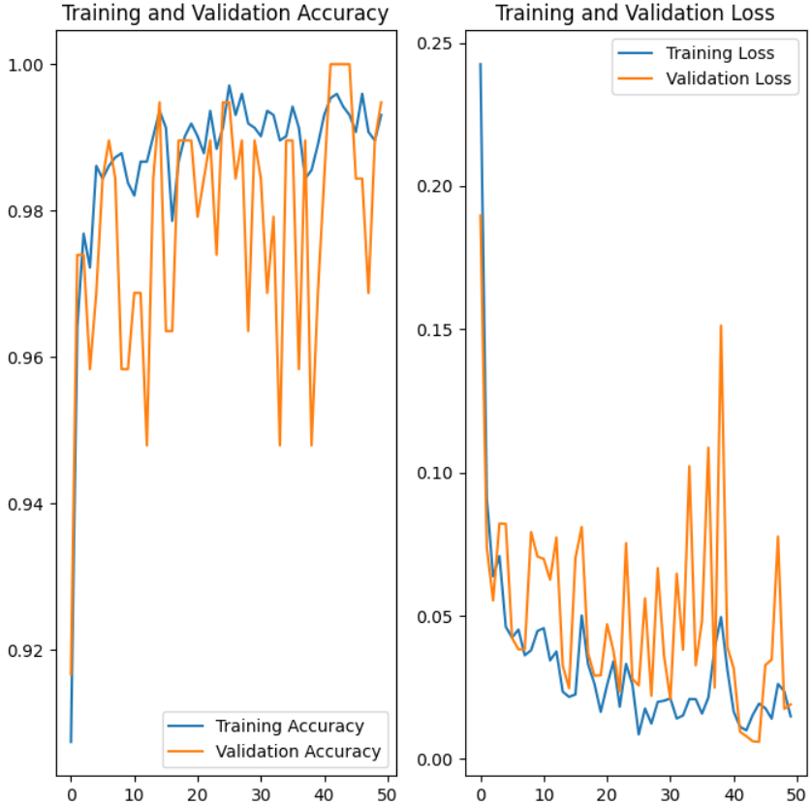

VGG16

